INTRODUCTION TO ELECTRICAL ENGINEERING [19AIE104]

S1 B.TECH CSE (AIE)

**AUTOMATIC ROOM LIGHTING SYSTEM**

A Project Report

*Submitted b*y

ROLL NUMBER NAME

*AM.EN.U4AIE21056 S HARI SANKAR*

*AM.EN.U4AIE21036 K SUBHASH*

*AM.EN.U4AIE21057 SAI MANASA SOUMYA*

*AM.EN.U4AIE21051 CHARISHMA AKSHAYA*

*AM.EN.U4AIE21052 R RAKESH*

**

AMRITA SCHOOL OF ENGINEERING

AMRITA VISHWA VIDYAPEETHAM

AMRITAPURI 690 525

January 2022

**ABSTRACT**

Automatic Room Lights System using Arduino is a very useful project as you need not worry about turning on and off the switches every time you want to turn on the lights.

In this project, we will see the automatic room lighting system using Arduino and PIR sensor where the lights in a room will automatically turn ON and OFF by detecting human presence.

The main components of the Automatic Room Lights project are Arduino, PIR Sensor and the Relay Module.

Out of the three components, the PIR Sensor is the one in focus as it is the main device that helps in detecting humans and human motion.

In fact, the Automatic Room Lights project can be considered as one major application of the PIR Sensor. A similar concept is being already implemented in automatic toilet flushes, hand dryers, etc.

Also, with the assistance of this system, we can save the energy bill as power will be consumed only when human is present i.e., when required lights will be spontaneously turned ON or OFF.

Such Automatic Room Lights systems can be implemented in your Classrooms, faculty cabins, garages, staircases, bathrooms, etc. where we do not need constant light but only when individuals are existing. Also, with the assistance of this system, we can save the energy bill as power will be consumed only when human is present i.e. when required lights will be spontaneously turned ON or OFF.

**TABLE OF CONTENTS**

|  |  |
| --- | --- |
|  |  |

1. INTRODUCTION 4
2. COMPONENTS REQUIRED 5
3. CIRCUIT DIAGRAM 6
4. WORKING OF THE SYSTEM 7-8
5. RESULT AND ANALYSIS9
6. CONCLUSION 9
7. APPENDIX 10-11
8. REFERENCES 12

**I.INTRODUCTION**

Scientific discoveries delivered us luxury and comforts. Technology has become vital and essential part of our lives. Tremendous advancement in technology is succeeded in last few years. Electrical energy has become a crucial part of human life. In recent years the people are looking forward for the automation in their day-to-day life, and even now the people are excited to save energy consumed to reduce the expenditures. People are becoming lazy to switch off the lights while leaving the room, so the large amount of energy is wasted if the light is remained ON in the absence of human being. Generally, in public and private sector companies, offices, school and colleges most of the people are not interested to switch OFF the electronic machines like fan, light, etc., while going out of the room. As more and more electronic equipments and appliances are used in our day-to-day life the demand for power and energy consumption in every area tends to grow. Moreover, power is wasted in the absence of human beings in public and private sectors

Using the concept of automation in controlling the lighting system, power consumption can be comprehensively reduced which will further reduce the wastage of electricity which will in turn help in saving money to the owner. Furthermore, this system is a perfect example of automation which can be implemented in our day to day life which will reduce human efforts. This are the main enhancements of the projected system.

The main parts of the proposed system are Arduino, PIR Sensor and the Relay Module. This system can be considered as a major application of PIR sensors

**II.COMPONENTS REQUIRED**

* **Arduino UNO**
* **PIR Sensor**
* **Relay Module**
* **Bulb**
* **Power Supply**
* **1000Ω Resistor**
* **Connecting Wires**
* **Breadboard**

**III. CIRCUIT DIAGRAM**

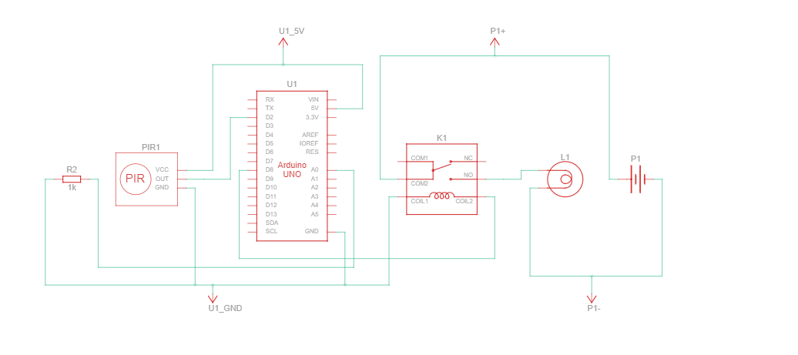

**IV. WORKING OF THE SYSTEM**

Initially, when there is no human movement, the PIR Sensor doesn’t detect any person and its OUT pin stays LOW.

As the person enters the room, the change in infrared radiation in the room is detected by the PIR Sensor.As a result, the output of the PIR Sensor becomes HIGH. Since the Data OUT of the PIR Sensor is connected to Digital Pin 2 of Arduino, whenever it becomes HIGH, Arduino will activate the relay by making the relay pin LOW (as the relay module is an active LOW module).

This will turn the Light ON. The light stays turned ON as long as there is movement in front of the sensor.

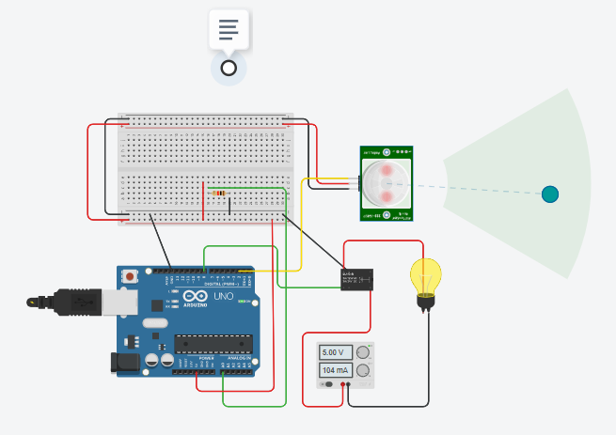

If the person takes a nap or leaves the room, the IR Radiation will become stable (there will be no change) and hence, the Data OUT of the PIR Sensor will become LOW. This in turn will make the Arduino to turn OFF the relay (make the relay pin HIGH) and the room light will be turned OFF.

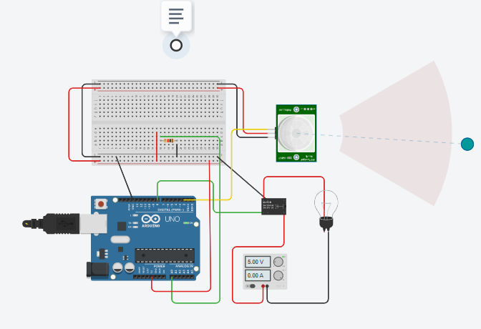

**V. RESULT AND ANALYSIS**

From this project, we can conclude that when a person enters the room the PIR Sensor automatically detects the motion due to infrared radiation and turns on the light, if there is no motion in the room for a specific time the PIR Sensor automatically turns off the light thereby saving electricity.

In the proposed system decision are taken based on presence of human but here we can also interface photoresistor along with PIR sensor for better working of the system. This system can also be interfaced with the Bluetooth module so the whole system can be controlled from the mobile by just single click. Applications of this system are:

1. It can be used in college labs, schools, etc.

2. It can also be used in bathrooms, staircases, etc. in the house.

**VI. CONCLUSION**

From the proposed system we can conclude that an approach is taken to control the room lights using various devices. As nowadays enormous amount of energy is wasted in daily life. With the help of this system the energy wastage can be preserved and can be contribute to large amount of power saving. The total effective cost for the system is also very less

**VII. APPENDIX**

//Automatic Room Lightning System

int PIRSensorVal = 0; //Input S

int RelayOutputVal = 0; //Output Relay

void setup()

{

pinMode(A0, INPUT); // Read the LDR sensor Value digital Input

pinMode(2, INPUT); // Read the PIR motion sensor value digital Input

pinMode(8, OUTPUT); // Write the Relay output value, digital output

Serial.begin(9600);

}

void loop()

{

PIRSensorVal = digitalRead(2);

RelayOutputVal = 8;

if (PIRSensorVal == HIGH) {

digitalWrite(8, HIGH);

delay(1500); // Wait for 5000 millisecond(s)

} else {

digitalWrite(8, LOW);

delay(1000); // Wait for 1000 millisecond(s)

}

}

**VIII. REFERENCES**

* <https://ijesc.org/upload/4bdd11226f4ddc3c472cb585b0e2448b.Automatic%20Room%20Light%20Controller%20using%20%20Arduino%20and%20PIR%20Sensor.pdf>
* <https://www.electronicshub.org/automatic-room-lights-using-arduino-pir-sensor/>
* <https://www.youtube.com/watch?v=BLfD816HWW0>